

### DISTRIBUTED COMPUTING

### (

**Chapter 2: Communication**

**

### LAYERED PROTOCOL

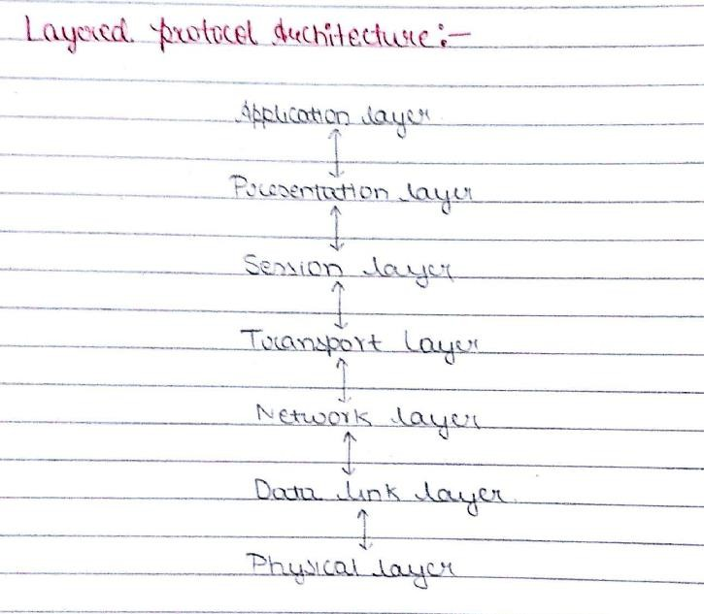

VIDYALANKAR INSTITUTE OF TECHNOLOGY (LMR OF DISTRIBUTED COMPUTING)

**TYPES OF COMMUNICATION**



⯈ Blocking (Synchronous)

⯈ Non-Blocking (Asynchronous)

⯈ Persistent

⯈ Transient



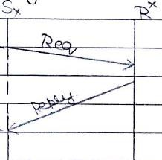

## BLOCKING AND NON BLOCKING

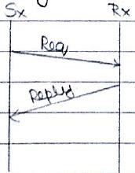

(LMR OF DISTRIBUTED COMPUTING)



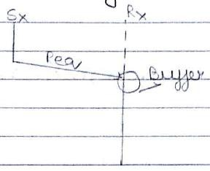

## PERSISTENT vs TRANSIENT

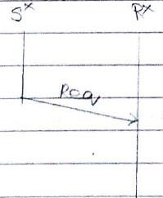



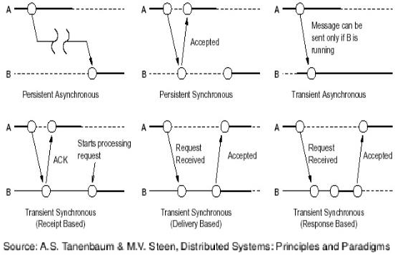

#### PERSISTENT AND TRANSIENT COMMUNICATION

VIDYALANKAR INSTITUTE OF TECHNOLOGY (LMR OF DISTRIBUTED COMPUTING)

## GROUP COMMUNICATION

⯈ 1-M

⯈ M-M

⯈ M-1

VIDYALANKAR INSTITUTE OF TECHNOLOGY (LMR OF DISTRIBUTED COMPUTING)





**ABSOLUTE CONSISTENT CAUSAL**

# ORDERING

VIDYALANKAR INSTITUTE OF TECHNOLOGY (LMR OF DISTRIBUTED COMPUTING



## MESSAGE BROKER ARCHITECTURE

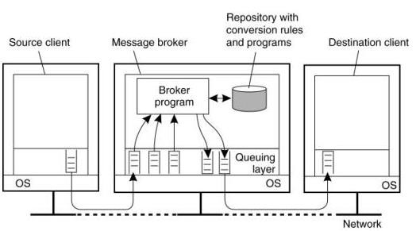

INSTITUTE OF TECHNOLOGY VIDYALANKAR (LMR OF DISTRIBUTED COMPUTING)



### STREAM ORIENTED COMMUNICATION

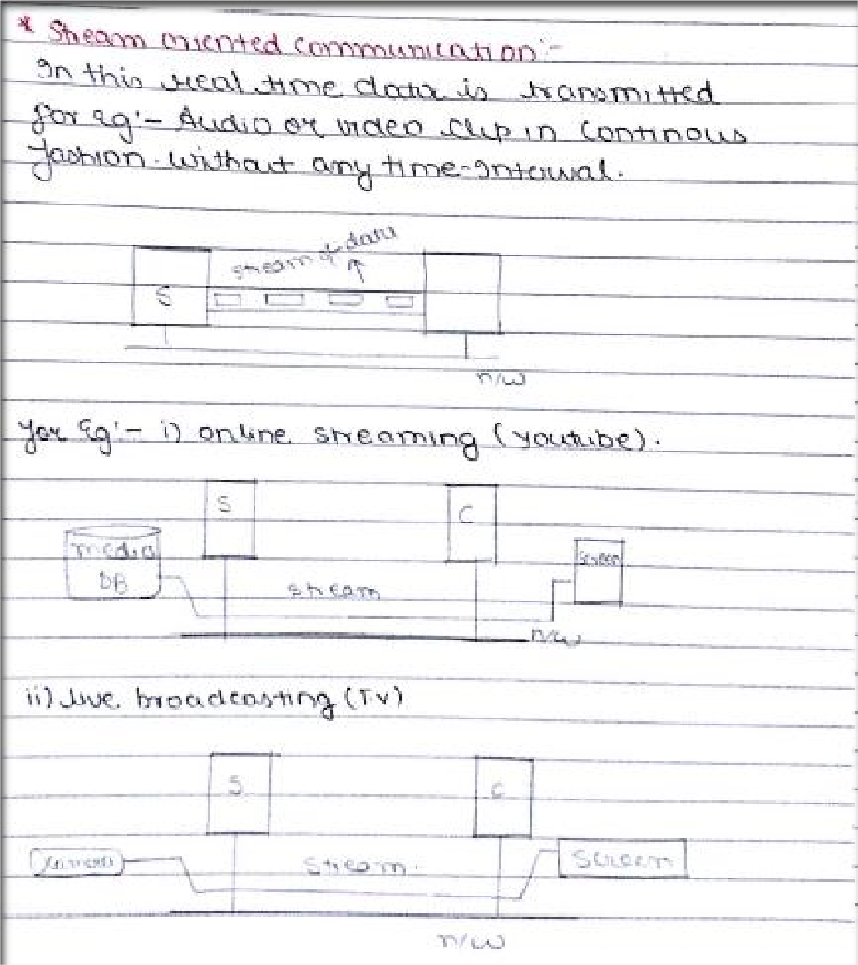

VIDYALANKAR INSTITUTE OF TECHNOLOGY (LMR OF DISTRIBUTED COMPUTING)



# RPC

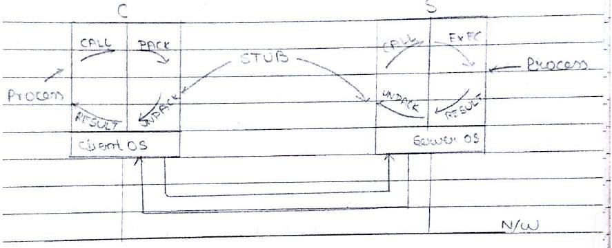

VIDYALANKAR INSTITUTE OF TECHNOLOGY (LMR OF DISTRIBUTED COMPUTING)

**RPC**

RPC Failures Solution

⯈ Lost Request

⯈ Lost Reply

⯈ Server Crash

⯈ Client Crash (Orphans and Grand

Orphans )

⯈ Timeout and Retransmission

⯈ Timeout and Retransmission

⯈ Timeout and Retransmission

⯈ Extermination, Re-incarnation,

Gentle Re-incarnation, Expiration

VIDYALANKAR INSTITUTE OF TECHNOLOGY (LMR OF DISTRIBUTED COMPUTING)

**RMI**

Image Source: https[://www.ejbtutorial.com/wp-content/uploads/2013/10/rmi-](http://www.ejbtutorial.com/wp-content/uploads/2013/10/rmi-) steps.png

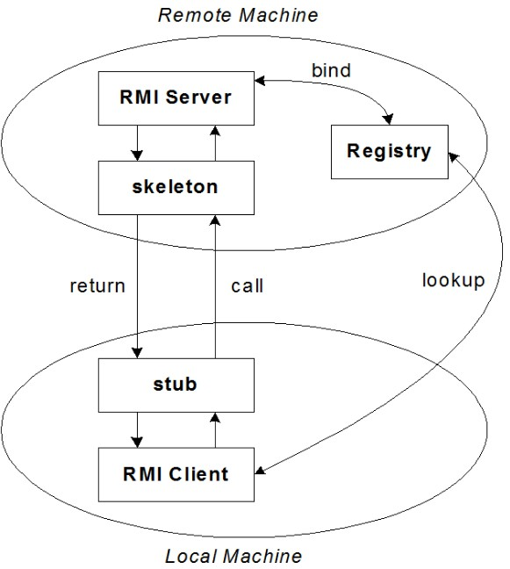

VIDYALANKAR INSTITUTE OF TECHNOLOGY (LMR OF DISTRIBUTED COMPUTING)

#### COMMUNICATION

⯈ **Types of Communication**

⯈ Synchronous

⯈ Asynchronous

⯈ Persistent

⯈ Transient

⯈ Group Communication

⯈ Types

⯈ 1-M

⯈ M-1

⯈ M-m

⯈ Ordering

⯈ Absolute

⯈ Consistent

⯈ Causal

⯈ Message Oriented Communication

⯈ Message Queuing

⯈ Message Broker

⯈ Stream oriented Communication

⯈ Live

⯈ Stored

|  |  |  |
| --- | --- | --- |
| ⯈ | **RPC** |  |
|  | ⯈ | **Model** |
|  | ⯈ | Failures |
| ⯈ | RMI |  |
|  | ⯈ | Model |

